Actions for this week:
Complete the preprocessing of the RealWorld dataset, revise the proposal under Dr Halloran’s guidance, obtain ethics approval, and find replacement datasets that are not from Kaggle or the UCI Machine Learning Repository.

What did I do this week? Why did I do this?
1. Continued working on the remaining preprocessing steps for the RealWorld dataset.
2. Asked my supervisor whether I am allowed to report the performance of some models on datasets from the UCI Machine Learning Repository in the dissertation.
3. Used the ethics system to confirm with my supervisor that my chosen datasets are not from Kaggle or the UCI Machine Learning Repository.
4. Repeatedly revised the proposal under my supervisor’s guidance and suggestions. The main goal was to avoid making the proposal too dense, and to improve its readability so that it is understandable to non-experts.

Why:
1. Preprocessing the RealWorld dataset is the first and fundamental task in my whole experimental project. Only by successfully completing the preprocessing can I ensure that the subsequent models can be trained and tested properly on the dataset.
2–3. Asking my supervisor early about whether a dataset is allowed, and getting ethics approval as soon as possible, are both critical. They determine how early I can start the experiments. If my ethics approval were delayed until mid or late October, the time left for experiments would be heavily compressed.
2. Supervisor Halloran is the main person responsible for my project: he provides guidance, sets expectations for assessment and decides on the marking criteria. All my work needs to be aligned with his expectations as much as possible before I proceed.

Outcomes and findings:
1. I successfully completed all preprocessing steps for the RealWorld dataset.
2. My supervisor said I need to clearly confirm that the datasets I use do not come from Kaggle or the UCI Machine Learning Repository. Therefore, I switched to alternative datasets that are not from those sources.
3. My ethics application was approved by my supervisor.
4. By searching on Google, I found some highly readable and strong proposal examples from around the world to use as references, and I revised my own proposal four times.

Reflection:
1. I finished all preprocessing for the first dataset in early October, which means my progress is currently reasonable. I should deliberately leave time to revise the proposal, because the proposal is due on the 13th of October, whereas the final dissertation is only due on the 4th of December. I need to prioritise tasks correctly.
2–3. Previously, I assumed the worst-case scenario: that any dataset which has ever appeared on Kaggle or the UCI Machine Learning Repository cannot be used. Judging from my supervisor’s reply, that assumption was correct, and fortunately I had already found alternative datasets in advance.
2. Supervisor Halloran requires the proposal to be readable and friendly to non-experts. This has been the most challenging part for me this week. In the past, when I read journal and conference papers, I noticed that their information density is very high and the technical content is written in a very complex way, making them almost impossible for non-specialists to understand. Previous coursework assignments did not explicitly require high readability, so I never developed that habit.

This is a big challenge for me. At first, I did not know how to turn something complex into writing that others can easily understand. But when I think about it, I have often struggled to read certain journal and conference papers myself, because they are written in an overly complicated way. Articles that are too dense and obscure often make readers lose interest. Writing complex technical content in a complex style is easy; what really shows a person’s ability is writing about complex topics in a way that is clear and engaging. I need to adapt to this writing style as soon as possible.

I also realised that if someone writes a proposal to apply for project funding or a PhD place, and the proposal is so complex that reviewers cannot understand it, then they will not be able to move forward with their plans either.

Have I finished this week’s action? What percentage? If not, how to improve?
Completion rate: 80 percent.
The proposal is still too dense, and its readability is not high enough.

Actions for next week:
Improve the readability of the proposal, define and explain technical terms clearly, and send the final draft to my supervisor before noon on Monday, 13 October. Train and test several baseline models on the fully preprocessed RealWorld dataset to inspect the initial results.

Conversation/email record with my supervisor, Halloran:
(All four revised versions of the proposal, updated according to my supervisor’s requirements, have been uploaded to GitHub: Computing-project/Project process/week 4 10.06–10.12.)

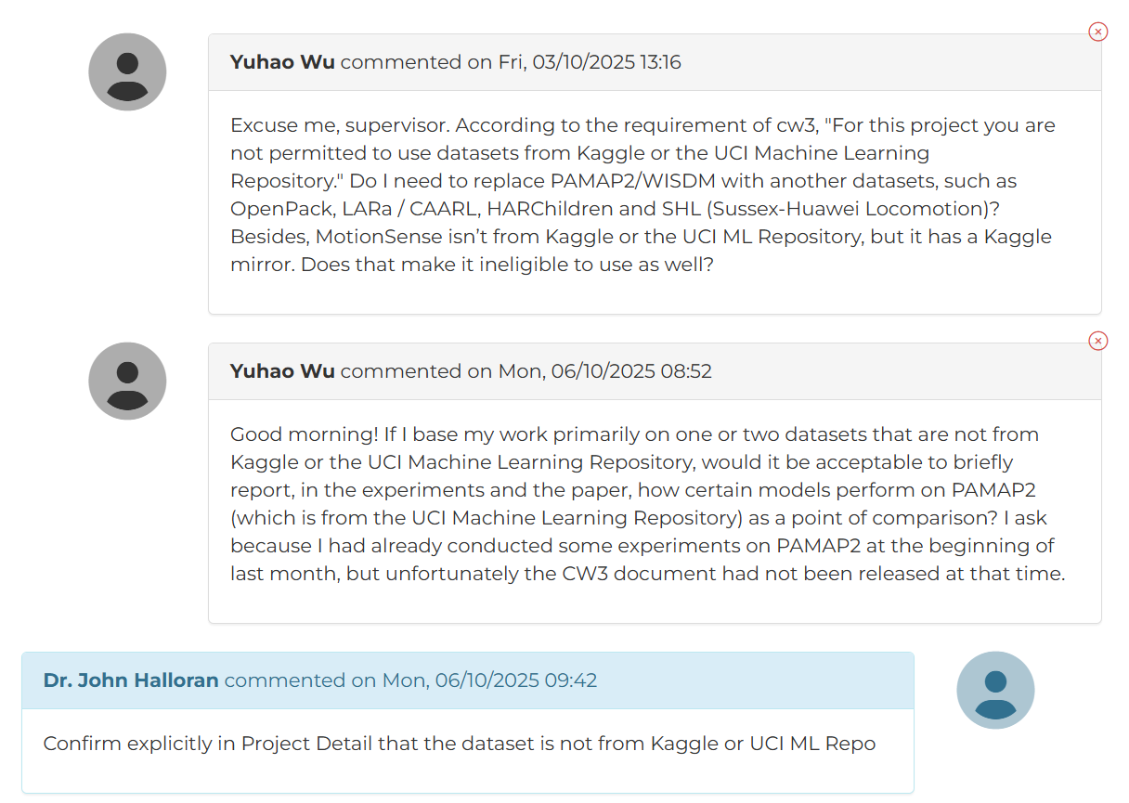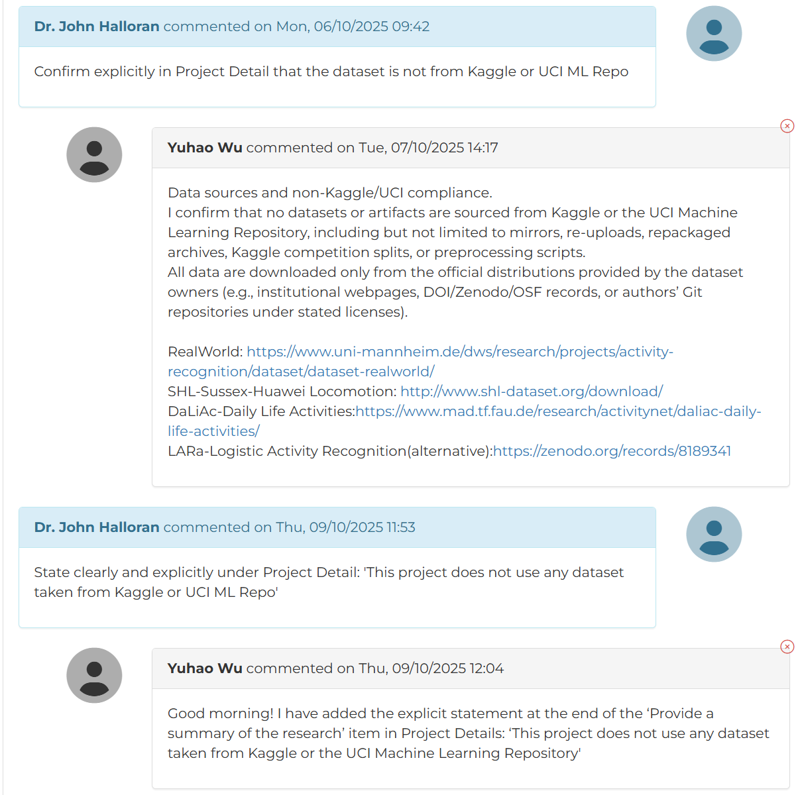
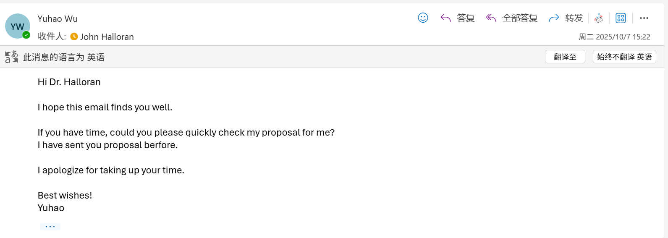
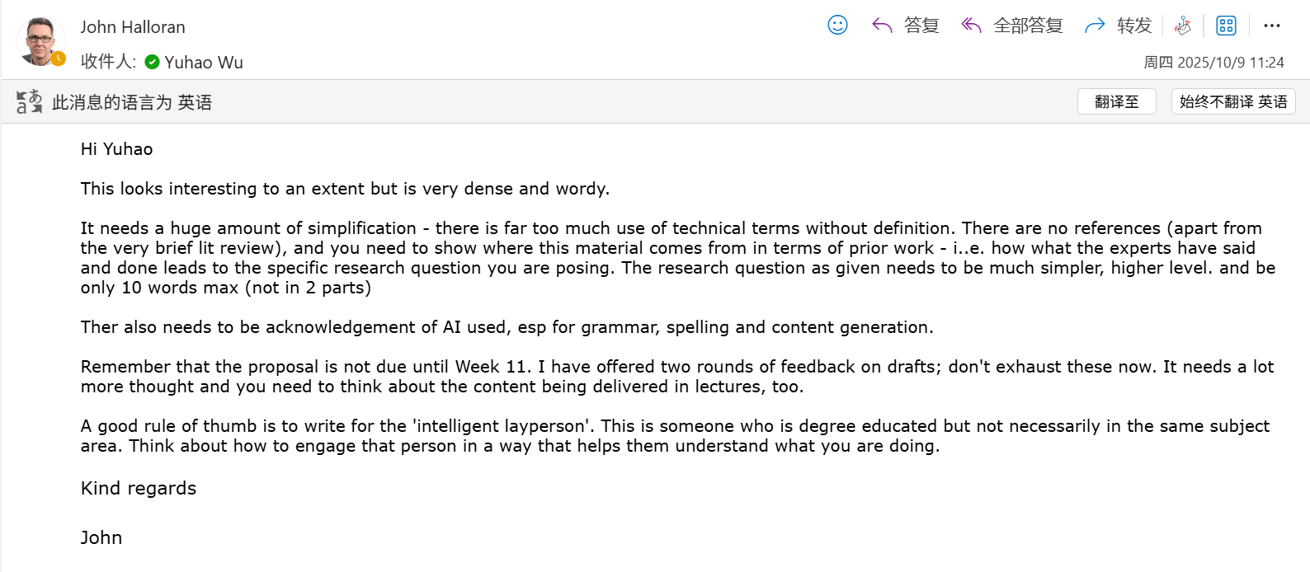
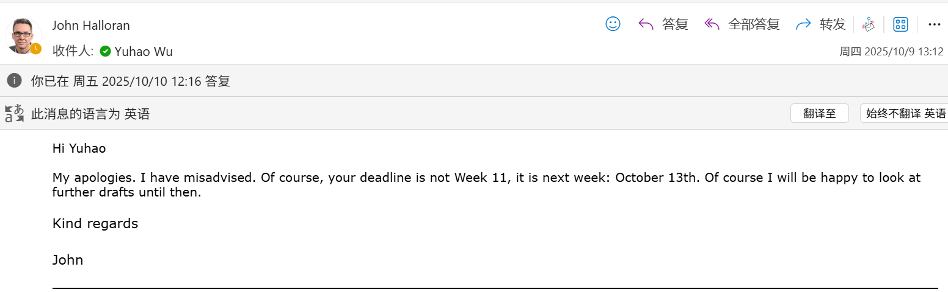
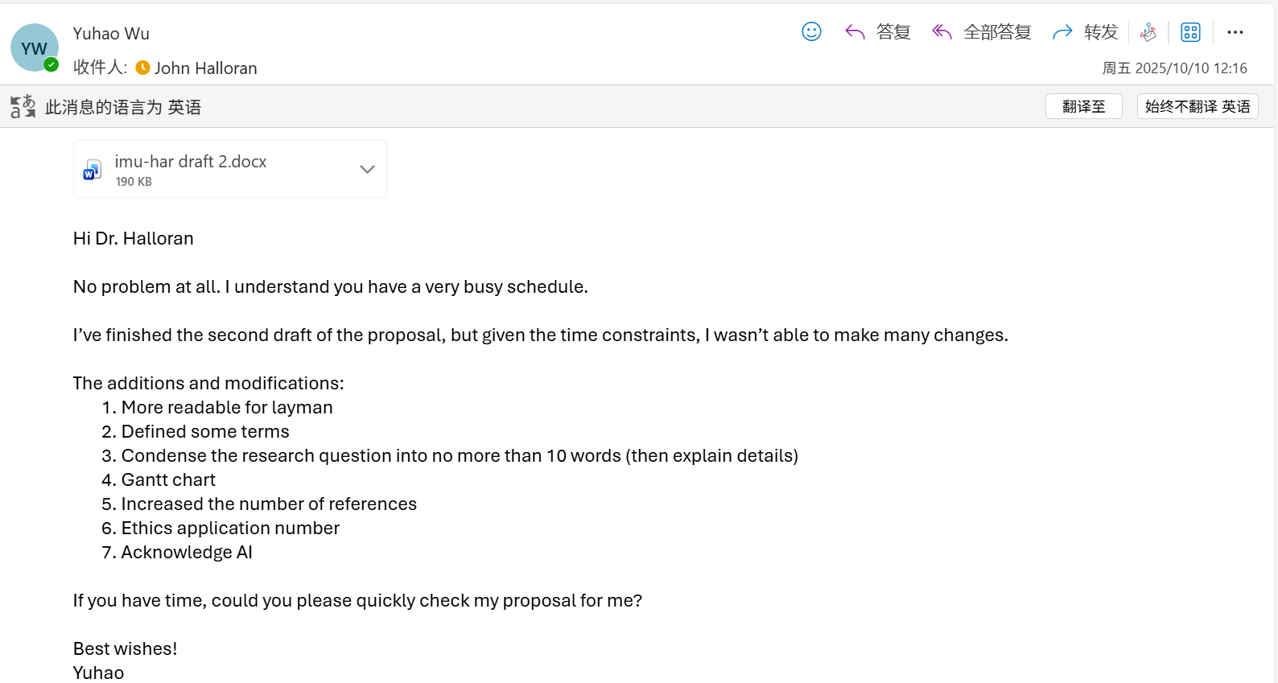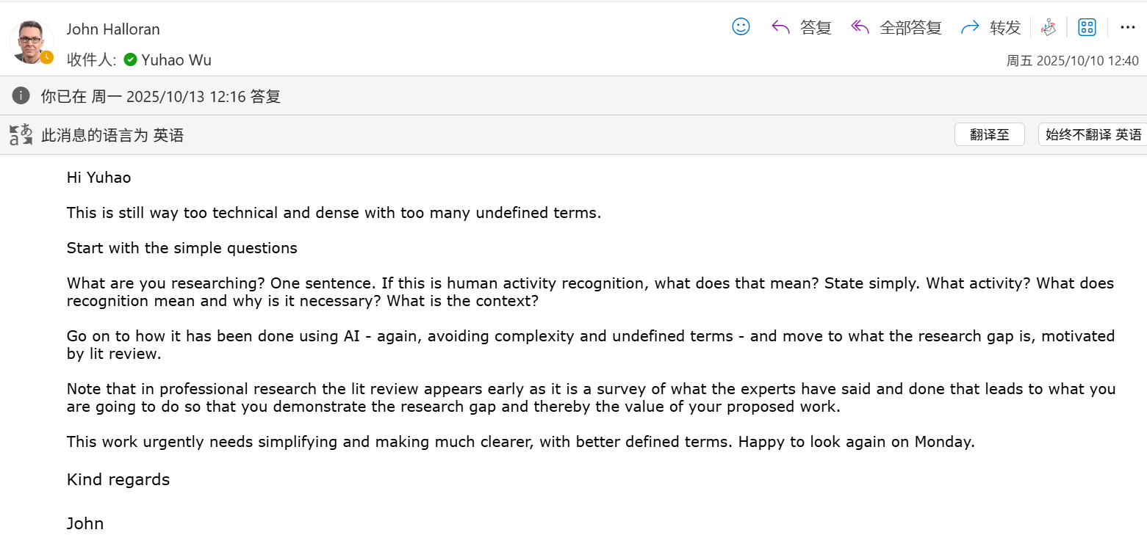

Meeting part:
I asked my supervisor, John Halloran, two questions.
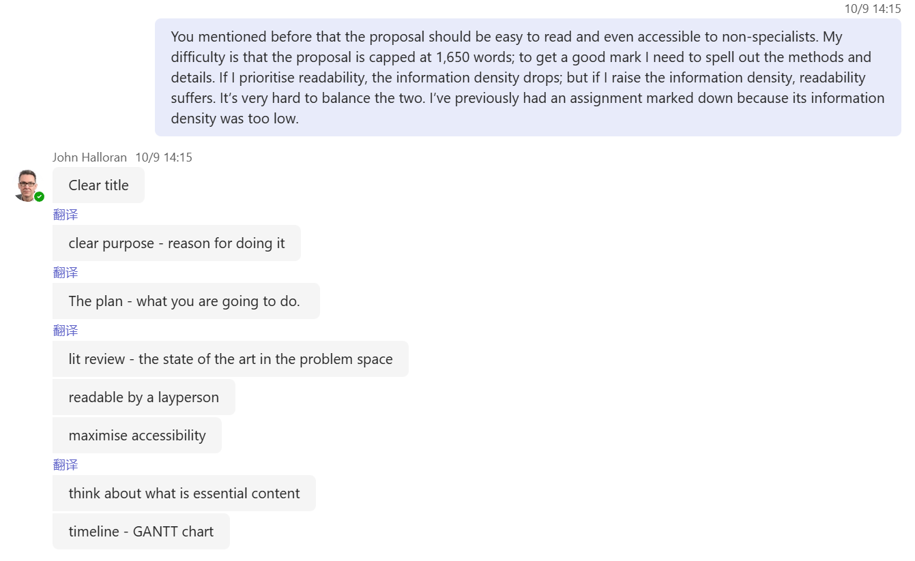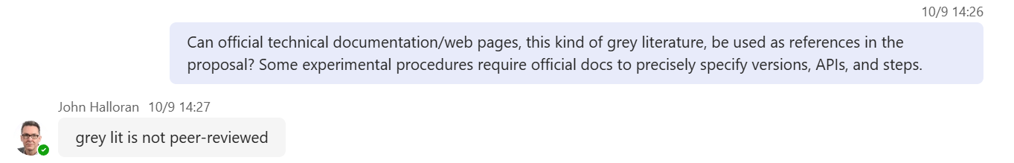
For my first question, his answer was:
“You are absolutely right. This is indeed a trade-off between readability and information density. At the moment, your proposal really is too dense. Some of the terminology or content may be unfamiliar to newcomers in this field. A ‘layperson’ means anyone you might meet on the street: an intelligent person, possibly with a university degree, but not necessarily from a computer science background. They could be anyone. Any good piece of research, including highly professional work, should still be understandable to laypeople.

In other words, the reader may not follow every single detail you write, but at least at a high level they should be able to benefit from your work and understand what you are talking about. All professional researchers have a duty to maximise the accessibility of their work. ‘Maximise accessibility’ means we should try to broaden our readership as much as possible. Good research needs a wider audience.

This also means that, for example, if you use a technical term such as ‘random forest’. Many proposals or projects mention this method, but a lot of people never explain what a random forest actually is or how it works.

A good piece of work will tell the reader what a random forest is and how it operates. I agree with you, Yuhao — doing this is indeed difficult, because it increases the word count and forces you to compress other parts. There is a word limit, the maximum is 1,650 words. You are right about that.

So it really is hard, but this is exactly why this is a master’s-level assignment — it is supposed to be challenging. A master’s degree sits just one level below a PhD. So from undergraduate to master’s to PhD, every step becomes more demanding.

You need to make decisions about which details to keep and which to cut. Yuhao, your proposal is very detailed and information-rich. I suggest you compress it and keep only the most central and necessary content. You can think about how to optimise it in this way.”

My improvement: I rewrote the proposal to make it more readable (see the files “week 3 9.29–10.05 imu-har” and “week 4 10.06–10.12 imu-har draft 2”).
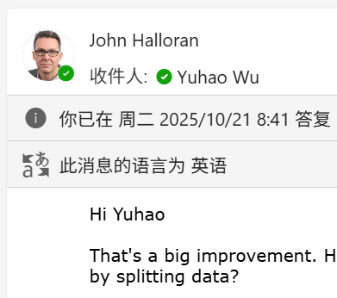
For my second question, his answer was:
“I am a professional researcher and have been doing research for many years. I myself often use ‘grey literature’. The term ‘grey literature’ refers to material that has not been peer-reviewed.

Grey literature includes magazine articles, news reports, blogs, Wikipedia and so on. Wikipedia is a classic example of something that is not peer-reviewed. Anything that is not published in an academic journal, conference proceedings or scholarly monograph counts as grey literature.

‘Peer-reviewed’ means that the material has been examined by other experts. This is why academic journal articles are so important: their quality is checked by other specialists. Grey literature does not go through this kind of review. Anyone can publish grey literature online. Newspapers, for instance, are grey literature because they are not academically reviewed; they are only checked by editorial teams.

However, in some cases you can use grey literature. For example, suppose you read a news article stating: ‘The latest advances in generative AI may cause many people to lose their jobs in the future.’ That could spark your research interest. You might then decide to investigate whether this claim is true, and if so, which industries would be most affected. In this sense, grey literature can be useful: it can inspire new research questions, even if it is not academic material itself.

Newspapers and magazines often spot emerging issues earlier than academia. They sometimes identify a trend first, and then academic research follows up. In such cases, it is acceptable to use grey literature.”

What I did: In “week 4 10.06–10.12 imu-har draft 2” I cited a small amount of grey literature.
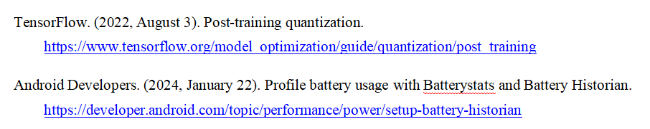
Because my supervisor showed us a Gantt chart, I asked him whether including a Gantt chart in the proposal would be a good idea. John Halloran responded positively and said yes.

My improvement: I therefore included a Gantt chart in the next proposal draft.
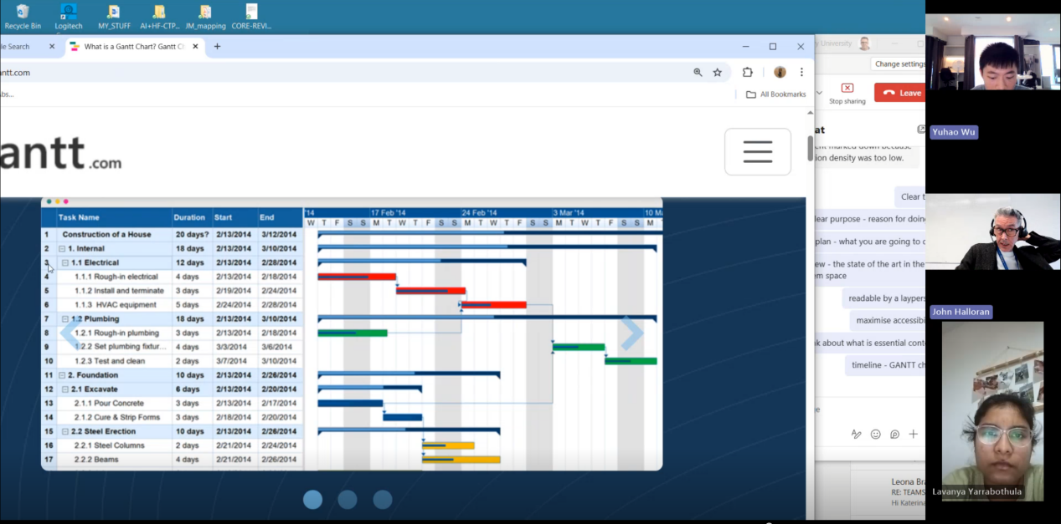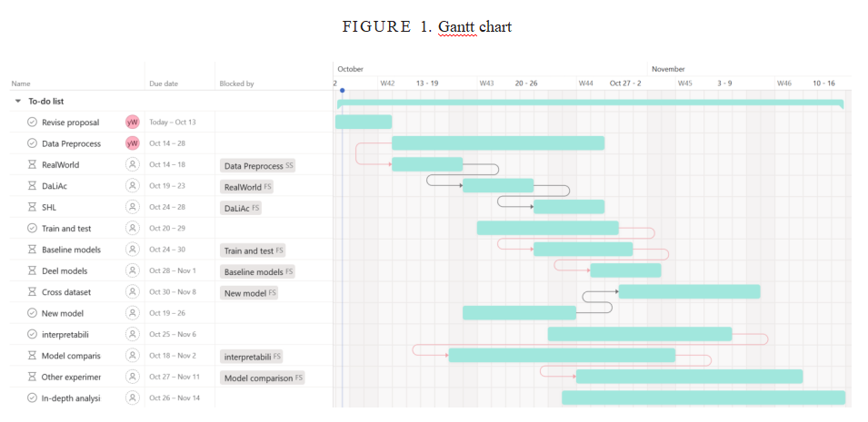

All important points my supervisor, John Halloran, has mentioned:

1. Recording and materials
I am allowed to record meetings myself; my supervisor does not mind and said this is completely fine.

2. Ethics application versus research proposal
These are completely different things:

* Ethics application: This is only for review/approval and is not graded. Its purpose is to give me permission to carry out my research in an ethical way (in line with the law and accepted norms in computer science).
* Research proposal: This is marked and used to assess the quality of my research idea, planning and design (0–100 marks).

Ethics approval does not equal proposal approval, and vice versa:

* It is possible to have an excellent proposal that cannot be approved ethically (for example, John mentioned a recent student who wanted to research neurodivergent users; the idea was interesting but could not get ethics approval).
* The ethics form can reuse the “project summary” and “project details” from the proposal, but the ethics review does not judge the academic quality of the proposal.

Common checks in the ethics application:

* No human participants, children, dangerous chemicals or drugs, etc. In CS projects, serious ethics issues are relatively rare.

For my case: my machine learning project, dataset and data sources have already been confirmed, and my supervisor has approved my ethics application.

3. Deadlines, grace period and extensions
At that point there were only three working days left: today, tomorrow and Monday.

* Official deadline: 13th at 18:00.
* Technical grace period: 24 hours, so the very latest submission time is 14th at 18:00, but this is only for genuine technical problems.
* The supervisor can still give feedback on Monday, but I must send a draft by Monday midday at the latest to leave a few hours for comments.

Extensions:

* It is possible to apply for an extra 5 days, but this requires evidence (usually medical; late registration can also be a reason but does not apply to me).
* Extensions normally need to be requested about two weeks before the deadline.
* From our discussion, it sounded like I would not be applying for an extension.

4. What we needed to do immediately (submission rhythm)
To get feedback:

* I had to send a draft to my supervisor by Friday midday; that way he could give feedback on Friday.
* He said he would send an email explaining the marking/feedback timeline, but he needs to see a draft first.

I then emailed him my second draft.

5. Proposal structure and “essential content”
My proposal contained a lot of material, but many methodological and process details can be left for the later project and do not need to be fully expanded in the proposal.

The proposal should focus on “essential content”:

* A clear title.

* A clear research purpose and motivation (why this project).

* A clear plan (what I will do), broken down into work packages over weeks:

For example: what will be done in weeks 1–2? Weeks 2–3? Weeks 3–4?
Use small headings with bullet points for key tasks; describe methods only at a summary level.

* Literature review (as section 4): this should explain the state of the art in the problem domain:

* What experts have already done; what we already know.
* Which open problems and gaps remain.
* How to avoid simply repeating existing work.
* How my research connects to these open problems, and why it is necessary and novel (why it is needed, why it has not been done before, with evidence from expert literature).

* The timeline is very important. John strongly recommends using a Gantt chart to show when different activities will happen.

6. Concrete suggestions for the Gantt chart
A Gantt chart is not mandatory, but very useful. It can be created in Excel or Word (John also showed an example from gantt.com).

The idea:

* Put the time axis at the top.
* List key tasks below (for example, in the example he gave about building a house: foundations, pouring concrete, steel frame, electrical work, etc.).
* Keep the chart simple and show only the most important tasks; details can be added later.

John said my current proposal reads more like a finished dissertation than a proposal. It needs to be simplified. A good proposal should be easy to understand, have a clear plan, and provide clear reasons for doing the project.

7. Readability and audience (“maximising accessibility”)
The proposal should be understandable to a “smart layperson”: someone who may have a university degree but not in computer science.

Even professional research should allow a non-specialist reader to understand the main ideas:

* We should maximise accessibility, meaning we try to widen the audience for our work.
* Technical terms should be defined and explained (for example, what a random forest is and how it works; we should not assume the reader already knows).
* There is a word limit of 1,650 words, so we must balance readability and information density.

John said my draft was too dense and I should keep only the core material.

8. Use of grey literature
Grey literature can be used, but not too much.

Definition:

* Grey literature is material that has not been peer-reviewed, such as magazines, newspapers, blogs, Wikipedia, official websites/technical documentation, etc.
* This contrasts with journal articles, conference papers and academic books, which are peer-reviewed.

Peer review means experts have checked the quality of the work, which is why journal articles are so important. Grey literature does not go through this process; anyone can publish it.

Value of grey literature:

* It often raises important issues earlier than academic work.
* It can inspire research questions.
For example: a news article says “generative AI will cause large-scale unemployment”. This could lead to academic research asking whether the claim is true, and which sectors might be affected.
* Other examples: interfaces between large language models and robots, responsibility in self-driving car accidents, and similar topics.

However, a literature review cannot rely only on “Google hits”. If almost all sources are grey literature, it will make the supervisor worry that there is no solid academic foundation. Academic sources should form the core, with grey literature used sparingly and only when closely relevant.

9. Other tips and actions

* John prepared an explanatory document and shared it in the chat.
* He will send an email outlining the marking/feedback timeline.
* He again emphasised: to get timely feedback, I must submit a draft by Friday midday. He can also give feedback on Monday, but I still need to submit by Monday midday and allow a few hours for him to read it.

